A000-EUR-Greece-Archaic-Standing Woman with Himation, Chiton-Late Archaic-early 550 BCE

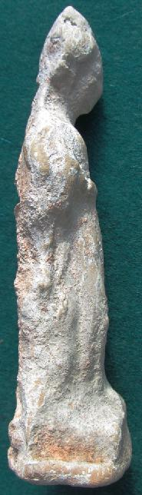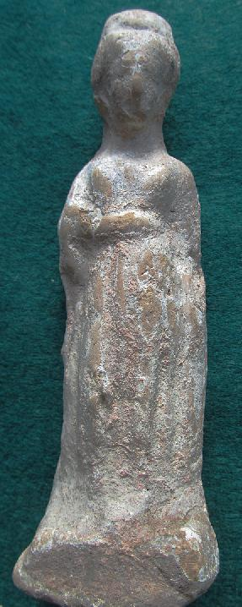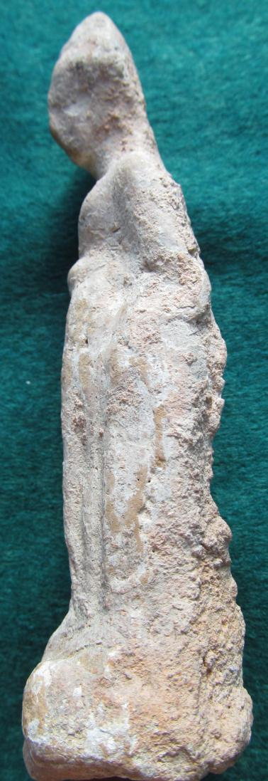

Greece-Archaic-Standing Woman with Himation, Chiton-Late Archaic-early 550 BCE

Case No.: 4

Accession No.

Formal Label: Greece-Archaic-Standing Woman with Himation, Chiton-Late Archaic-early 550 BCE

**Display Description:**

Late Archaic statuette of a woman in a votive stance with her head slightly bowed in deference to a deity. Archaic Greek religion was personal, direct, and present in all areas of life as this terra cotta statuette of a woman suggests. Rituals such as animal sacrifices and libations, myths to explain the origins of mankind and temples which dominated the urban landscape with its city festivals and national sporting and artistic competitions, religion was never far from the mind of an ancient Greek. The individual may have made up their own mind on the degree of their religious belief and some may have been neutral certain fundamentals must have been sufficiently widespread in order for Greek government and society to function: the gods existed, they could influence human affairs, and they welcomed and responded to acts of piety and worship. This statuette suggests these acts of piety impacted the populace.

Accession Number:

**LC Classification: BL782.B83**

Date or Time Horizon: 550 BCE

Geographical Area: Athens

**Map:**

**GPS coordinates:**

Cultural Affiliation: Archaic Greece

Media: terra cotta

Dimensions:

Weight:

Condition: original

Provenance:

**Discussion:**

**References:**

Burkert, Walter. 1985. *Greek Religion: Archaic and Classical*. Cambridge: Harvard University Press.